FINAL PROJECT

IN OOP

**DEAL OR NO DEAL**

**Submitted by: Section: E32**

**RIVERA, JOHNDELL**

**TOLIBAS, JAMMELA**

**VALLEJO, GIULIANO**

**VITOR, ART DOMINICK**

**ZABALA, KYLE**

**Submitted to:**

**Prof Beau Gray Habal**

**Deal or No Deal**

is a [British](https://en.wikipedia.org/wiki/Television_in_the_United_Kingdom) [game show](https://en.wikipedia.org/wiki/Game_show), based on the [format which originated in the Netherlands](https://en.wikipedia.org/wiki/Deal_or_No_Deal) that ran from 2005 to 2016. The show featured a single contestant trying to beat the Banker as they open 26 identical sealed red boxes assigned to potential contestants in an order of their choosing.

Objectives:

* The player’s aim is to sell that box back to The Banker (or the program itself) for the most amount of money possible.
* The highest winning possible prize is ₱2M

Mechanics:

* It starts with 26 identical boxes.
* There are 25 boxes on the wings each containing an amount of money between ₱1 and ₱2M.
* At the start of the game the player selects a numbered box at random.
* In the first round the player must choose six boxes before the first offer from the program
* The banker places his opening offer into the output.
* The program will ask, “Deal or No Deal?” The player must answer, “Deal” to accept the offer or “No Deal” to decline the offer and carry on.
* five boxes are opened in the second round, followed by the question from the program.
* On the third round, you’ll only choose four boxes only.
* On the fourth round, you’ll only choose three boxes only.
* On the fifth round, you’ll only choose two boxes;
* And on the six to eight round, you’ll only choose one box.
* If you decide to “No Deal” each of the round, you will continue in this fashion until only two boxes remain.
* When the last two boxes remain, The program will give his final offer. If you say “No Deal” you will then go through to the final box which you have chosen.
* If you say “Deal” you will get the prize whatever the program has been offered to you.
* You will then win whatever is in the box on the table and this will be opened to reveal what you have won.

**SOURCE CODES**

package dornd;

import java.awt.*;

import javax.swing.*;

import java.awt.event.*;

import java.util.*;

import javax.swing.border.Border;

public final class DealNoDeal implements ActionListener {

public static int[] value = {

1,

5,

10,

25,

50,

75,

100,

200,

300,

400,

500,

750,

1000,

5000,

10000,

25000,

50000,

75000,

100000,

200000,

300000,

400000,

500000,

750000,

1000000,

2000000

};

public static String[] label = {

" ₱ 1",

" ₱ 5",

" ₱ 10",

" ₱ 25",

" ₱ 50",

" ₱ 75",

" ₱ 100",

" ₱ 200",

" ₱ 300",

" ₱ 400",

" ₱ 500",

" ₱ 750",

" ₱ 1,000",

" ₱ 5,000",

" ₱ 10,000",

" ₱ 25,000",

" ₱ 50,000",

" ₱ 75,000",

" ₱ 100,000",

" ₱ 200,000",

" ₱ 300,000",

" ₱ 400,000",

" ₱ 500,000",

" ₱ 750,000",

" ₱ 1,000,000",

" ₱ 2,000,000"

};

public static Scanner in = new Scanner(System.in);

public static money[] box_money = new money[26];

public static ArrayList<Integer> ij = new ArrayList<>(26);

public static String ch;

public static int max;

public static int min;

public static int nxt;

public static int max_index;

public static int min_index;

public static int nxt_index;

public static int count;

public static int s = 7;

public static int chosen = 0;

JFrame game;

JLayeredPane all = new JLayeredPane();

JLayeredPane win = new JLayeredPane();

JLayeredPane menu = new JLayeredPane();

JPanel left = new JPanel();

JPanel right = new JPanel();

JPanel center = new JPanel();

JPanel field = new JPanel();

JPanel title = new JPanel();

JPanel r_tit_no = new JPanel();

JPanel r_tit_dl = new JPanel();

JPanel r_corner = new JPanel();

JPanel l_corner = new JPanel();

JPanel over = new JPanel();

JPanel bank_lbl = new JPanel();

JPanel bank_txt = new JPanel();

JPanel bank_txt_win = new JPanel();

JPanel p_congrats = new JPanel();

JPanel p_youwon = new JPanel();

JPanel p_newg = new JPanel();

JPanel menubox = new JPanel();

JPanel names = new JPanel();

JPanel mechs = new JPanel();

JButton[] boxes = new JButton[26];

JButton deal = new JButton("DEAL");

JButton nodeal = new JButton("NO DEAL");

JButton newg = new JButton("New Game");

JButton start = new JButton("START GAME");

JButton ex_g = new JButton("Exit Game");

JButton play = new JButton("Play Game");

JButton cred = new JButton("Game Credits");

JButton inst = new JButton("Instructions");

JButton[] tomenu = new JButton[2];

JLabel[] sides = new JLabel[26];

JLabel lbl_case = new JLabel(" YOUR CASE # IS:");

JLabel txt_case = new JLabel("");

JLabel lbl_round = new JLabel(" ROUND");

JLabel txt_round = new JLabel();

JLabel bg = new JLabel(new ImageIcon("C:\\Users\\Hyndal\\Downloads\\OOP\\DORND\\dond.jpg"));

JLabel m = new JLabel(new ImageIcon("C:\\Users\\Hyndal\\Downloads\\OOP\\DORND\\menu.png"));

JLabel t_dl = new JLabel(" DEAL");

JLabel t_no = new JLabel(" NO");

JLabel t_or = new JLabel(" OR");

JLabel t_nd = new JLabel(" DEAL");

JLabel lbl_bank = new JLabel(" Banker's Offer: ");

JLabel txt_bank = new JLabel();

JLabel txt_bank_win = new JLabel();

JLabel congrats = new JLabel(" CONGRATULATIONS!!!");

JLabel youwon = new JLabel(" You Won: ");

JLabel t_field = new JLabel();

JLabel cross = new JLabel(" Cross Vallejo");

JLabel dell = new JLabel(" Johndell Rivera");

JLabel jam = new JLabel(" Jamela Tolibas");

JLabel art = new JLabel(" Art Vitor");

JLabel kyle = new JLabel(" Kyle Zabala");

JLabel cross1 = new JLabel(" Analyzer");

JLabel dell1 = new JLabel(" Documenter");

JLabel jam1 = new JLabel(" Designer");

JLabel art1 = new JLabel(" Debugger");

JLabel kyle1 = new JLabel(" Developer");

JLabel d1 = new JLabel(" DEAL OR NO DEAL GAME PROJECT");

JLabel d2 = new JLabel(" SUBMITTED TO PROF. BEAU GRAY HABAL");

JLabel d3 = new JLabel(" CPEOOP E32 SY 2017-2018 Term 3");

JLabel d4 = new JLabel(" GROUP 10 10 n n July 3, 2018");

JLabel r1 = new JLabel(" ROUND 1: Choose a case number to keep.");

JLabel r2 = new JLabel(" ROUND 2: Eliminate 6 cases, Deal or No Deal?!.");

JLabel r3 = new JLabel(" ROUND 3: Eliminate 5 cases, Deal or No Deal?!.");

JLabel r4 = new JLabel(" ROUND 4: Eliminate 4 cases, Deal or No Deal?!.");

JLabel r5 = new JLabel(" ROUND 5: Eliminate 3 cases, Deal or No Deal?!.");

JLabel r6 = new JLabel(" ROUND 6: Eliminate 2 cases, Deal or No Deal?!.");

JLabel rf = new JLabel(" ROUND F: Eliminate 1 case, Deal or No Deal?!.");

DealNoDeal() {

/* ___ _ __ __ ___ ___ ___ ___ ___ ___ _ _

/ __| /_\ | \/ | __| / __|/ __| _ \ __| __| \| |

| (_ |/ _ \| |\/| | _| \__ \ (__| / _|| _|| .` |

\___/_/ \_\_| |_|___| |___/\___|_|_\___|___|_|\_|

*/

//Frame Design

game = new JFrame();

game.setLayout(null);

game.setSize(11*7+70*7+s*5+131*2, 131+s*(21)+23*13);

game.setResizable(false);

game.setDefaultCloseOperation(JFrame.DISPOSE_ON_CLOSE);

game.setVisible(true);

//Title Panel Design

all.add(title);

title.setLayout(null);

title.setBackground(new Color(20,20,20,200));

title.setOpaque(true);

title.setBounds(131+s*2, s, 11*7+70*7+1, 91);

title.add(t_dl);

t_dl.setFont(new Font("Arial", Font.BOLD, 46));

t_dl.setBorder(BorderFactory.createLineBorder(Color.yellow, 10));

t_dl.setForeground(Color.yellow);

t_dl.setBackground(Color.black);

t_dl.setLayout(null);

t_dl.setOpaque(true);

t_dl.setBounds(s, s, 175, 91-s*2);

title.add(t_or);

t_or.setFont(new Font("Arial", Font.BOLD, 30));

t_or.setForeground(Color.yellow);

t_or.setLayout(null);

t_or.setBounds(s*2+175, s, 55, 91-s*2);

title.add(t_no);

t_no.setFont(new Font("Arial", Font.BOLD, 50));

t_no.setBorder(BorderFactory.createLineBorder(Color.yellow, 5));

t_no.setForeground(Color.yellow);

t_no.setBackground(Color.black);

t_no.setLayout(null);

t_no.setOpaque(true);

t_no.setBounds(s*3+175+60, s, 115, 91-s*2);

title.add(t_nd);

t_nd.setFont(new Font("Arial", Font.BOLD, 56));

t_nd.setForeground(Color.black);

t_nd.setBackground(Color.yellow);

t_nd.setLayout(null);

t_nd.setOpaque(true);

t_nd.setBounds(s*3+175+115+60, s, 11*7+70*7+1-175-60-115-s*4, 91-s*2);

//Banker Panel Design

all.add(bank_lbl);

bank_lbl.setBackground(new Color(20,20,20,200));

bank_lbl.setOpaque(true);

bank_lbl.setBounds(s*5+131, s*7+150, 11*7+70*6+65-s*5, 50);

bank_lbl.setVisible(false);

bank_lbl.add(lbl_bank);

lbl_bank.setBounds(s+(11*7+70*6+65-s*5)/2-90+s, s*12, 180-s*2, 20+s*2);

lbl_bank.setFont(new Font("Arial", Font.BOLD, 20));

lbl_bank.setBorder(BorderFactory.createLineBorder(Color.yellow, 3));

lbl_bank.setForeground(Color.yellow);

//Banker Text Design

all.add(bank_txt);

bank_txt.setBackground(new Color(20,20,20,200));

bank_txt.setOpaque(true);

bank_txt.setBounds(s*5+131, s*7+150+50, 11*7+70*6+65-s*5, 100);

bank_txt.setVisible(false);

bank_txt.add(txt_bank);

txt_bank.setBounds(s, s*15+70, 11*7+70*6+65-s*7, 70);

txt_bank.setFont(new Font("Arial", Font.PLAIN, 50));

txt_bank.setForeground(Color.yellow);

//Left Panel Design

all.add(left);

left.setLayout(null);

left.setBackground(new Color(20,20,20,200));

left.setBounds(s, s, 131, s*(14)+23*13);

left.setOpaque(true);

//Left Corner Panel Design

all.add(l_corner);

l_corner.setBounds(s, s*(16)+23*13,131,131);

l_corner.setLayout(null);

l_corner.setBackground(new Color(20,20,20,200));

l_corner.setOpaque(true);

//Deal Button Design

l_corner.add(deal);

deal.setBounds(s*2, s*2+15, 131-s*4, 131-s*4-30);

deal.setBorder(new Rounded(25));

deal.setFont(new Font("Arial", Font.BOLD, 20));

deal.addActionListener(this);

//Your Case Number Design

l_corner.add(lbl_case);

lbl_case.setBounds(s*2, s, 131-s*4, 25);

lbl_case.setLayout(null);

lbl_case.setBorder(BorderFactory.createLineBorder(Color.yellow, 1));

lbl_case.setForeground(Color.yellow);

l_corner.add(txt_case);

txt_case.setBounds(65-33, s*2+30, 67, 60);

txt_case.setLayout(null);

txt_case.setOpaque(true);

txt_case.setBackground(Color.darkGray);

txt_case.setBorder(BorderFactory.createLineBorder(Color.yellow, 1));

txt_case.setForeground(Color.yellow);

txt_case.setFont(new Font("Arial", Font.BOLD, 53));

//Right Panel Design

all.add(right);

right.setLayout(null);

right.setBackground(new Color(20,20,20,200));

right.setBounds(11*7+70*7+131+s*3, s, 131, s*(14)+23*13);

right.setOpaque(true);

//Right Corner Panel Design

all.add(r_corner);

r_corner.setBounds(11*7+70*7+131+s*3, s*(16)+23*13, 131, 131);

r_corner.setLayout(null);

r_corner.setBackground(new Color(20,20,20,200));

r_corner.setOpaque(true);

//No Deal Button Design

r_corner.add(nodeal);

nodeal.setBounds(s*2, s*2+15, 131-s*4, 131-s*4-30);

nodeal.setBorder(new Rounded(25));

nodeal.setFont(new Font("Arial", Font.BOLD, 12));

nodeal.addActionListener(this);

//Round Number Design

r_corner.add(lbl_round);

lbl_round.setBounds(s*2+25, s, 131-s*4-50, 25);

lbl_round.setLayout(null);

lbl_round.setBorder(BorderFactory.createLineBorder(Color.yellow, 1));

lbl_round.setForeground(Color.yellow);

r_corner.add(txt_round);

txt_round.setBounds(65-33, s*2+30, 67, 60);

txt_round.setLayout(null);

txt_round.setOpaque(true);

txt_round.setBackground(Color.darkGray);

txt_round.setBorder(BorderFactory.createLineBorder(Color.yellow, 1));

txt_round.setForeground(Color.yellow);

txt_round.setFont(new Font("Arial", Font.BOLD, 53));

//Side Labels Design

for(int i=0; i<26; i++) {

int j = i%13;

sides[i] = new JLabel(label[i]);

if(i<13) left.add(sides[i]);

else right.add(sides[i]);

sides[i].setLayout(null);

sides[i].setBounds(s, s*(j+1)+23*j, 131-s*2, 23);

sides[i].setForeground(Color.yellow);

sides[i].setBorder(BorderFactory.createLineBorder(Color.yellow, 1));

}

//Center Panel Design

all.add(center);

center.setLayout(null);

center.setBounds(s*2+131, s*2+91, 11*7+70*7+1, s*(16)+23*13-91);

center.setBackground(new Color(20,20,20,100));

//Buttons Design

for(int i=0; i<26; i++) {

int t=11;

boxes[i] = new JButton(Integer.toString(i+1));

center.add(boxes[i]);

boxes[i].addActionListener(this);

boxes[i].setBorder(new Rounded(20));

if(i>=20 && i<26) boxes[i].setBounds(t*(i-16)+70*(i-20)+7, t+s*2, 60, 45);

if(i>=13 && i<20) boxes[i].setBounds(t*(i-12)+70*(i-13), t*2+77, 60, 45);

if(i>=6 && i<13) boxes[i].setBounds(t*(i-5)+70*(i-6), t*3+145, 60, 45);

if(i>=0 && i<6) boxes[i].setBounds(t*(i+4)+70*(i)+7, s*(14)+23*13-91-t-45, 60, 45);

}

//Field Panel Design

all.add(field);

field.setBounds(s*2+131, s*3+91+(s*(16)+23*13-91), 11*7+70*7+1, 110) ;

field.setBackground(new Color(20,20,20,150));

//Field Label Designs

field.add(t_field);

t_field.setText(" Choose the case number you want to keep!!! ");

t_field.setForeground(Color.yellow);

t_field.setFont(new Font("Arial", Font.BOLD, 23));

//Main Layered Panel Design

game.add(all);

all.setLayout(null);

all.setBackground(Color.black);

all.setOpaque(true);

all.setBounds(0, 0, 11*7+70*7+s*5+131*2, 131+s*(17)+23*13);

//Main Panel Image Label

all.add(bg);

bg.setBounds(0, 0, 11*7+70*7+s*5+131*2, 131+s*(17)+23*13);

bg.setOpaque(true);

bg.setLayout(null);

/* __ _____ _ _ _ _ ___ ___ ___ ___ ___ ___ ___ _ _

\ \ / /_ _| \| | \| | __| _ \ / __|/ __| _ \ __| __| \| |

\ \/\/ / | || .` | .` | _|| / \__ \ (__| / _|| _|| .` |

\_/\_/ |___|_|\_|_|\_|___|_|_\ |___/\___|_|_\___|___|_|\_|

*/

//Winner Layered Panel Design

game.add(win);

win.setLayout(null);

win.setBackground(Color.black);

win.setOpaque(true);

win.setBounds(0, 0, 11*7+70*7+s*5+131*2, 131+s*(17)+23*13);

win.setVisible(false);

//Winner Congrats Panel Design

win.add(p_congrats);

p_congrats.setBackground(new Color(20,20,20,200));

p_congrats.setOpaque(true);

p_congrats.setLayout(null);

p_congrats.setBounds(s*5+91, s*7+100, 11*7+70*6+100-s, 70+s*2);

p_congrats.add(congrats);

congrats.setBounds(s, s, 11*7+70*6+100-s*3, 70);

congrats.setFont(new Font("New Courier", Font.BOLD, 50));

congrats.setForeground(Color.yellow);

//You Won Panel Design

win.add(p_youwon);

p_youwon.setBackground(new Color(75,75,75,20));

p_youwon.setOpaque(true);

p_youwon.setBounds(s*5+293, s*7+200, 11*7+70*2, 70);

p_youwon.add(youwon);

youwon.setBounds(s*2, s*2, 200, 40);

youwon.setOpaque(true);

youwon.setBackground(new Color(255,255,0,150));

youwon.setFont(new Font("New Courier", Font.BOLD, 20));

youwon.setForeground(Color.black);

youwon.setBorder(BorderFactory.createLineBorder(Color.black, 2));

//Winning Amount Design

win.add(bank_txt_win);

bank_txt_win.setBackground(new Color(20,20,20,200));

bank_txt_win.setOpaque(true);

bank_txt_win.setBounds(s*5+131, s*7+250, 11*7+70*6+65-s*5, 100);

bank_txt_win.add(txt_bank_win);

txt_bank_win.setBounds(s, s*15+70, 11*7+70*6+65-s*7, 70);

txt_bank_win.setFont(new Font("Arial", Font.PLAIN, 50));

txt_bank_win.setForeground(Color.yellow);

//New Game & Exit Button

win.add(p_newg);

p_newg.setBackground(new Color(20,20,20,200));

p_newg.setOpaque(true);

p_newg.setBounds(s*5+131, s*7+350, 11*7+70*6+65-s*5, 50);

p_newg.add(newg);

newg.addActionListener(this);

p_newg.add(ex_g);

ex_g.addActionListener(this);

/* ___ ___ _ _ ___ _ _ ___ ___ ___ ___ ___ _ _

/ __| _ \ | /_\ / __| |_| | / __|/ __| _ \ __| __| \| |

\__ \ _/ |__ / _ \\__ \ _ | \__ \ (__| / _|| _|| .` |

|___/_| |____/_/ \_\___/_| |_| |___/\___|_|_\___|___|_|\_|

*/

//WALA PA

/* __ __ ___ _ _ _ _ ___ ___ ___ ___ ___ _ _

| \/ | __| \| | | | | / __|/ __| _ \ __| __| \| |

| |\/| | _|| .` | |_| | \__ \ (__| / _|| _|| .` |

|_| |_|___|_|\_|\___/ |___/\___|_|_\___|___|_|\_|

*/

//Deal or No Deal Main Panel

game.add(menu);

menu.setLayout(null);

menu.setBackground(Color.black);

menu.setOpaque(true);

menu.setBounds(0, 0, 11*7+70*7+s*5+131*2, 131+s*(17)+23*13);

//Menubox Panel

menu.add(menubox);

menubox.setOpaque(false);

menubox.setLayout(null);

menubox.setBounds(s*5+131, s*7+250, 11*7+70*6+65-s*5, 300);

//Buttons

menubox.add(play);

play.setBounds(s*3, s*3, 120, 50);

play.setBorder(new Rounded(25));

play.addActionListener(this);

menubox.add(inst);

inst.setBounds(s*5+170, s*3, 120, 50);

inst.setBorder(new Rounded(25));

inst.addActionListener(this);

menubox.add(cred);

cred.setBounds(s*7+170*2, s*3, 120, 50);

cred.setBorder(new Rounded(20));

cred.addActionListener(this);

for(int i=0; i<2; i++) {

tomenu[i] = new JButton("Back to Menu");

menu.add(tomenu[i]);

tomenu[i].setBounds(s*85-2, s*62-i*50, 120, 30);

tomenu[i].addActionListener(this);

tomenu[i].setVisible(false);

}

//Project Details

menu.add(names);

names.setLayout(null);

names.setBounds(s*2+131, s*2+91, 11*7+70*7+1, s*(16)+23*13-91);

names.setBackground(new Color(0,0,0,180));

names.setVisible(false);

names.add(d1);

d1.setBackground(Color.yellow);

d1.setOpaque(true);

d1.setForeground(Color.black);

d1.setFont(new Font("Arial", Font.BOLD, 15));

d1.setBounds(s*2, s*2, 11*7+70*7+1-s*4, 22);

names.add(d2);

d2.setBackground(Color.yellow);

d2.setOpaque(true);

d2.setForeground(Color.black);

d2.setFont(new Font("New Courier", Font.BOLD, 15));

d2.setBounds(s*2, s*2+22, 11*7+70*7+1-s*4, 22);

names.add(d3);

d3.setBackground(Color.yellow);

d3.setOpaque(true);

d3.setForeground(Color.black);

d3.setFont(new Font("New Courier", Font.BOLD, 15));

d3.setBounds(s*2, s*2+22*2, 11*7+70*7+1-s*4, 22);

names.add(d4);

d4.setBackground(Color.yellow);

d4.setOpaque(true);

d4.setForeground(Color.black);

d4.setFont(new Font("New Courier", Font.BOLD, 15));

d4.setBounds(s*2, s*2+22*3, 11*7+70*7+1-s*4, 22);

//Groupmember Names

names.add(dell);

dell.setForeground(Color.yellow);

dell.setFont(new Font("New Courier", Font.BOLD, 23));

dell.setBounds(95+s, s*18, 200, 25);

names.add(jam);

jam.setForeground(Color.yellow);

jam.setFont(new Font("Arial", Font.BOLD, 23));

jam.setBounds(95+s*2+1, s*20+25, 200, 25);

names.add(cross);

cross.setForeground(Color.yellow);

cross.setFont(new Font("Arial", Font.BOLD, 23));

cross.setBounds(95+s*5, s*22+25*2, 200, 25);

names.add(kyle);

kyle.setForeground(Color.yellow);

kyle.setFont(new Font("Arial", Font.BOLD, 23));

kyle.setBounds(95+s*8, s*24+25*3, 200, 25);

names.add(art);

art.setForeground(Color.yellow);

art.setFont(new Font("Arial", Font.BOLD, 23));

art.setBounds(95+s*13, s*26+25*4, 200, 25);

//Groupmember Roles

names.add(dell1);

dell1.setForeground(Color.yellow);

dell1.setOpaque(true);

dell1.setBackground(Color.black);

dell1.setBorder(BorderFactory.createLineBorder(Color.yellow, 1));

dell1.setFont(new Font("New Courier", Font.PLAIN, 19));

dell1.setBounds(s*2+280, s*18, 120, 25);

names.add(jam1);

jam1.setForeground(Color.yellow);

jam1.setOpaque(true);

jam1.setBackground(Color.black);

jam1.setBorder(BorderFactory.createLineBorder(Color.yellow, 1));

jam1.setFont(new Font("New Courier", Font.PLAIN, 19));

jam1.setBounds(s*2+280, s*20+25, 95, 25);

names.add(cross1);

cross1.setForeground(Color.yellow);

cross1.setOpaque(true);

cross1.setBackground(Color.black);

cross1.setBorder(BorderFactory.createLineBorder(Color.yellow, 1));

cross1.setFont(new Font("New Courier", Font.PLAIN, 19));

cross1.setBounds(s*2+280, s*22+25*2, 90, 25);

names.add(kyle1);

kyle1.setForeground(Color.yellow);

kyle1.setOpaque(true);

kyle1.setBackground(Color.black);

kyle1.setBorder(BorderFactory.createLineBorder(Color.yellow, 1));

kyle1.setFont(new Font("Arial", Font.PLAIN, 19));

kyle1.setBounds(s*2+280, s*24+25*3, 105, 25);

names.add(art1);

art1.setForeground(Color.yellow);

art1.setOpaque(true);

art1.setBackground(Color.black);

art1.setBorder(BorderFactory.createLineBorder(Color.yellow, 1));

art1.setFont(new Font("Arial", Font.PLAIN, 19));

art1.setBounds(s*2+280, s*26+25*4, 95, 25);

//Instructions Design

menu.add(mechs);

mechs.setBounds(s*2+131, s*2+150, 11*7+70*7+1, s*(17)+23*13-210);

mechs.setBackground(new Color(0,0,0,180));

mechs.setVisible(false);

mechs.add(r1);

r1.setForeground(Color.yellow);

r1.setFont(new Font("Arial", Font.PLAIN, 19));

mechs.add(r2);

r2.setForeground(Color.yellow);

r2.setFont(new Font("Arial", Font.PLAIN, 19));

mechs.add(r3);

r3.setForeground(Color.yellow);

r3.setFont(new Font("Arial", Font.PLAIN, 19));

mechs.add(r4);

r4.setForeground(Color.yellow);

r4.setFont(new Font("Arial", Font.PLAIN, 19));

mechs.add(r5);

r5.setForeground(Color.yellow);

r5.setFont(new Font("Arial", Font.PLAIN, 19));

mechs.add(r6);

r6.setForeground(Color.yellow);

r6.setFont(new Font("Arial", Font.PLAIN, 19));

mechs.add(rf);

rf.setForeground(Color.yellow);

rf.setFont(new Font("Arial", Font.PLAIN, 19));

//Deal or No Deal Main Image Label

menu.add(m);

m.setBackground(Color.black);

m.setBounds(0, 0, 11*7+70*7+s*5+131*2, 131+s*(17)+23*13);

m.setLayout(null);

//Start New Game

playgame();

}

@Override

public void actionPerformed(ActionEvent e) {

if(e.getSource() == deal) winner(1);

else if (e.getSource() == nodeal) {

int x=0;

while(!box_money[x].chosen) x++;

if(count<=3) winner(2);

else ret_box();

}

else if (e.getSource() == newg) {

game.dispose();

new DealNoDeal();

}

else if (e.getSource() == play) newgame();

else if (e.getSource() == cred) {

credits();

tomenu[0].setVisible(true);

}

else if (e.getSource() == inst) {

instruct();

tomenu[1].setVisible(true);

}

else if (e.getSource() == tomenu[0]) {

menubox.setVisible(true);

names.setVisible(false);

tomenu[0].setVisible(false);

}

else if (e.getSource() == tomenu[1]) {

menubox.setVisible(true);

mechs.setVisible(false);

tomenu[1].setVisible(false);

}

else if (e.getSource() == ex_g) game.dispose();

else {

for(int i=0; i<26; i++) {

if(e.getSource() == boxes[i]) {

boxes[i].setVisible(false);

if(count==26) {

choose(i);

break;

}

else {

next(i);

break;

}

}

}

roundcheck();

}

bg.setVisible(false);

bg.setVisible(true);

}

private static class Rounded implements Border {

private int radius;

Rounded(int radius) {

this.radius = radius;

}

public Insets getBorderInsets(Component c) {

return new Insets(this.radius+1, this.radius+1, this.radius+2, this.radius);

}

public boolean isBorderOpaque() {

return true;

}

public void paintBorder(Component c, Graphics g, int x, int y, int width, int height) {

g.drawRoundRect(x, y, width-1, height-1, radius, radius);

}

}

public void playgame() {

all.setVisible(false);

win.setVisible(false);

menu.setVisible(true);

}

public void newgame() {

//set menu layered pane to invisible

menu.setVisible(false);

//set congrats layered pane to invisible

win.setVisible(false);

//set main layered pane to visible

all.setVisible(true);

//set deal and nodeal buttons to invisible

deal.setVisible(false);

nodeal.setVisible(false);

//reset counters

count=0;

min=0;

max=0;

min_index=0;

max_index=0;

//buttons, boxes, and side labels set to visible

for(int i=0; i<26; i++) {

ij.add(i+1);

box_money[i] = new money();

box_money[i].label = label[i];

box_money[i].value = value[i];

box_money[i].chosen = false;

box_money[i].close();

boxes[i].setVisible(true);

sides[i].setVisible(true);

}

//jumbled indexes

Collections.shuffle(ij);

//reassign indices

for(int i=0; i<26; i++) {

int x = ij.get(i);

box_money[i].container = x;

}

//counters intialized

sort();

}

public void instruct() {

menubox.setVisible(false);

mechs.setVisible(true);

tomenu[1].setVisible(true);

}

public void credits(){

menubox.setVisible(false);

names.setVisible(true);

tomenu[0].setVisible(true);

}

public static void sort() {

//reset counters

count=0;

min=2000000;

max=1;

for(int i=0; i<26; i++) {

//check how many boxes are not chose yet

if(!box_money[i].isOpen && !box_money[i].chosen) count++;

//find highest value

if(box_money[i].value>max && !box_money[i].isOpen) {

max=box_money[i].value;

max_index=i;

}

//find smallest value

if(box_money[i].value<min && !box_money[i].isOpen) {

min=box_money[i].value;

min_index=i;

}

}

}

public static double bank() {

double offer=0;

//weighted mean of all unopened boxes

for(int i=0; i<26; i++) if(!box_money[i].isOpen) offer += ((double) box_money[i].value) * (1/(double)count);

//add relative mean

offer += ((double) max - (double) min)/(double) count;

return offer;

}

public void choose(int i) {

// ^

// pass chosen case's index as parameter

String ss;

if(i<9) ss=" ";

else ss="";

txt_case.setText(ss+Integer.toString(i+1));

//set box number to chosen but do not open it

box_money[ij.get(i)-1].chosen = true;

sort();

}

public void next(int i) {

// ^

// pass chosen case's index as parameter

//Open box

box_money[ij.get(i)-1].open();

sort();

//remove side label

sides[ij.get(i)-1].setVisible(false);

}

public String amount() {

double x;

int y;

String v;

String t="";

String u="";

int g=0;

x = bank()*100;

y = (int) x;

x = ((double) y)/100;

v = Double.toString(x);

for(int i=v.length()-1; i>=0; i--) {

if(v.charAt(i) == '.') {

for(int j=0; j<4; j++) t+=v.charAt(i-j);

t+=",";

i-=3;

} else t+=v.charAt(i);

}

for(int i=0; i<t.length(); i++) u+=t.charAt(t.length()-i-1);

return " ₱ "+u;

}

public void roundcheck() {

if(count==19 || count==14 || count==10 || count==7 || count==5 || count==4 || count==3) {

txt_case.setVisible(false);

lbl_case.setVisible(false);

txt_round.setVisible(false);

lbl_round.setVisible(false);

center.setVisible(false);

field.setVisible(false);

txt_bank.setText(amount());

bank_lbl.setVisible(true);

bank_txt.setVisible(true);

nodeal.setVisible(true);

deal.setVisible(true);

} else ret_box();

}

public void winner(int w) {

all.setVisible(false);

win.setVisible(true);

if(w==1) txt_bank_win.setText(amount());

if(w==2) {

for(int i=0; i<26; i++) {

if(box_money[i].chosen) {

txt_bank_win.setText(box_money[i].label);

break;

}

}

}

win.add(bg);

}

public void ret_box() {

bank_lbl.setVisible(false);

bank_txt.setVisible(false);

nodeal.setVisible(false);

deal.setVisible(false);

field.setVisible(true);

if(count>19 && count<=26) {

t_field.setText("Eliminate "+(count-19)+" more cases before Round 2!");

txt_round.setText(" 1");

}

if(count>14 && count<=19) {

t_field.setText("Eliminate "+(count-14)+" more cases before Round 3!");

txt_round.setText(" 2");

}

if(count>10 && count<=14) {

t_field.setText("Eliminate "+(count-10)+" more cases before Round 4!");

txt_round.setText(" 3");

}

if(count>7 && count<=10) {

t_field.setText("Eliminate "+(count-7)+" more cases before Round 5!");

txt_round.setText(" 4");

}

if(count>5 && count<=7) {

t_field.setText("Eliminate "+(count-5)+" more cases before Round 6!");

txt_round.setText(" 5");

}

if(count==5) {

t_field.setText("Eliminate 1 more case before Final Round!");

txt_round.setText(" 6");

}

if(count==4) {

t_field.setText("Eliminate 1 more case before winning!");

txt_round.setText(" F");

}

txt_case.setVisible(true);

lbl_case.setVisible(true);

txt_round.setVisible(true);

lbl_round.setVisible(true);

center.setVisible(true);

}

public static void main(String[] args) {

System.out.println( "DEAL OR NO DEAL GAME PROJECT\n" +

"SUBMITTED TO PROF. BEAU GRAY HABAL\n" +

"CPEOOP E32 S.y. 2017-2018 Term 3\n" +

" _ _ _ _ _ ___ _ \n" +

" _ | |___| |_ _ _ __| |___| | | | _ (_)_ _____ _ _ __ _ \n" +

" | || / _ \\ ' \\| ' \\/ _` / -_) | | | / \\ V / -_) '_/ _` | Documenter\n" +

" \\__/\\___/_||_|_||_\\__,_\\___|_|_| |_|_\\_|\\_/\\___|_| \\__,_| \n" +

"\n" +

" _ _ _____ _ _ _ \n" +

" _ | |__ _ _ __ ___| |__ _ |_ _|__| (_) |__ __ _ ___\n" +

" | || / _` | ' \\/ -_) / _` | | |/ _ \\ | | '_ \\/ _` (_-<\n" +

" \\__/\\__,_|_|_|_\\___|_\\__,_| |_|\\___/_|_|_.__/\\__,_/__/ Designer\n" +

"\n" +

" ___ __ __ _ _ _ \n" +

" / __|_ _ ___ ______ \\ \\ / /_ _| | |___ (_)___ \n" +

" | (__| '_/ _ (_-<_-< \\ V / _` | | / -_)| / _ \\ Analyzer\n" +

" \\___|_| \\___/__/__/ \\_/\\__,_|_|_\\___|/ \\___/\n" +

" |__/ \n" +

"\n" +

" _ __ _ ____ _ _ \n" +

" | |/ / _| |___ |_ /__ _| |__ __ _| |__ _ \n" +

" | ' < || | / -_) / // _` | '_ \\/ _` | / _` | \n" +

" |_|\\_\\_, |_\\___| /___\\__,_|_.__/\\__,_|_\\__,_| Developer\n" +

" |__/ \n" +

" _ _ __ ___ _ \n" +

" /_\\ _ _| |_ \\ \\ / (_) |_ ___ _ _ \n" +

" / _ \\| '_| _| \\ V /| | _/ _ \\ '_| \n" +

" /_/ \\_\\_| \\__| \\_/ |_|\\__\\___/_| Debugger");

new DealNoDeal();

}

}

package dornd;

public class money {

int value;

String label;

boolean isOpen;

boolean chosen;

int container;

public money() {

value=0;

label="";

isOpen=false;

container=0;

chosen = false;

}

public void close() {

isOpen = false;

}

public void open() {

isOpen = true;

}

}

**SAMPLE OUTPUT**

**Menu**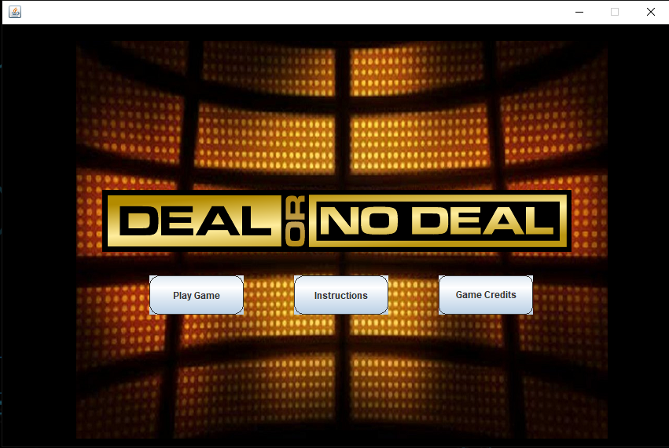

**CREDITS**

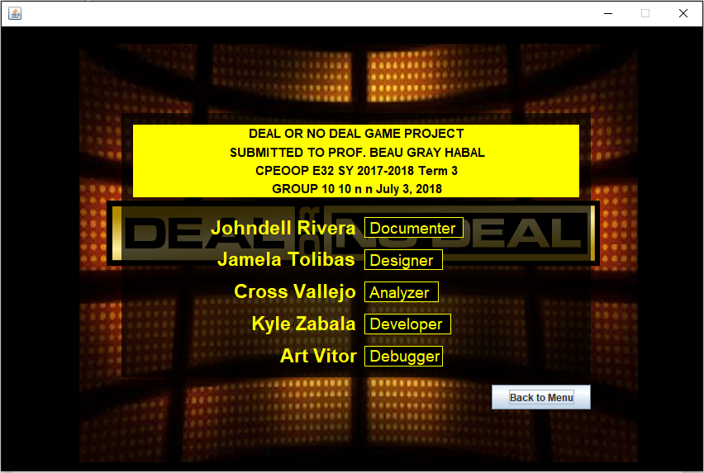

**INSTRUCTIONS**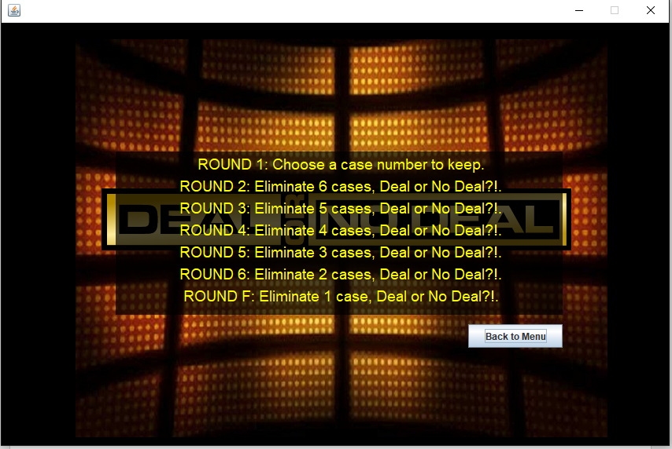

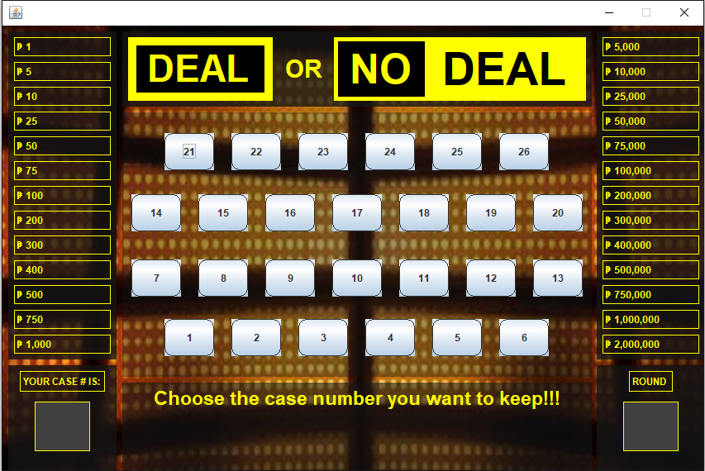**START OF GAME**

**ROUND 1**

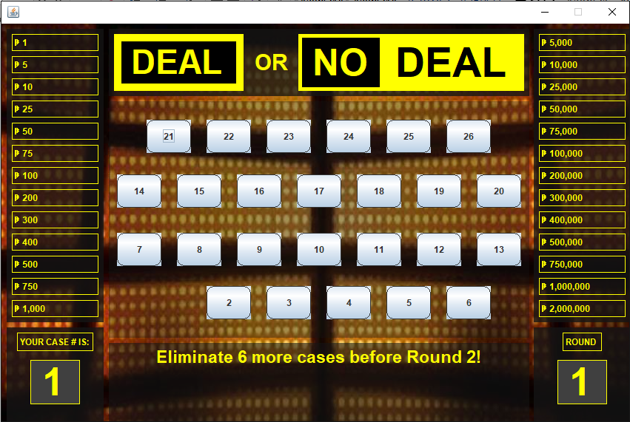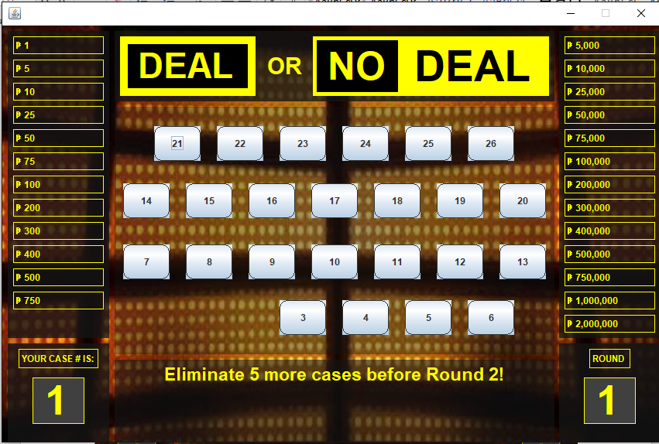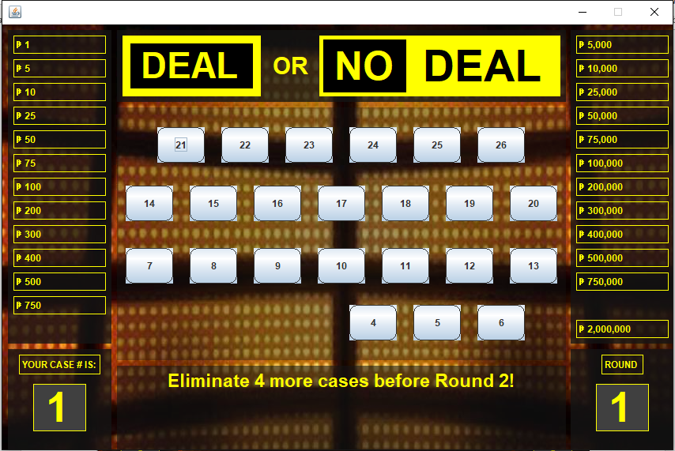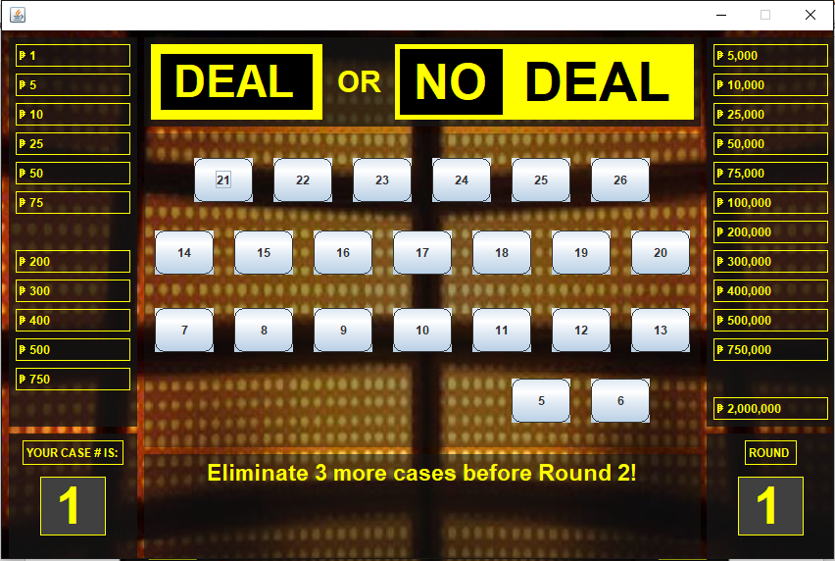

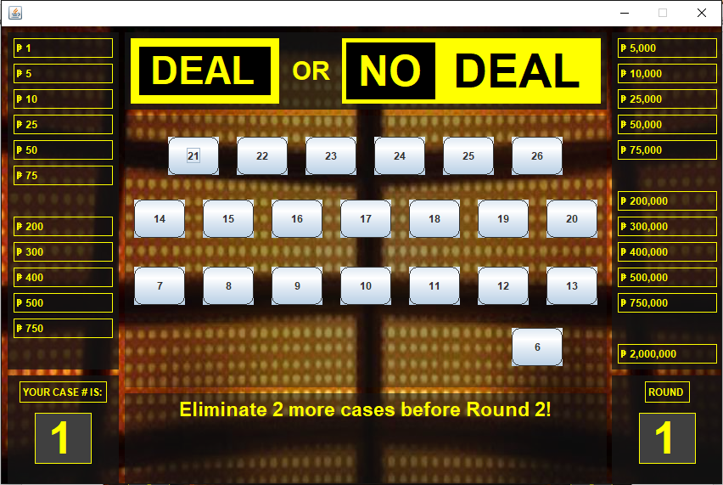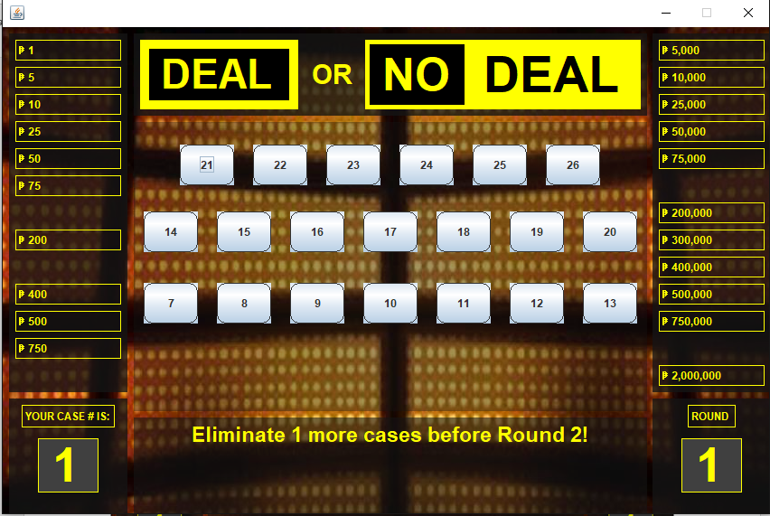

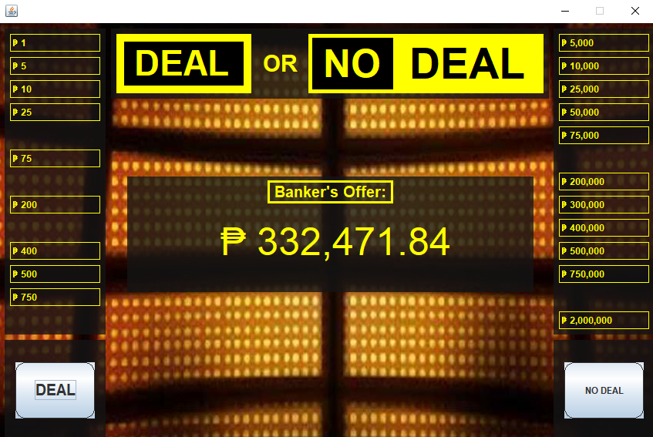**1ST DEAL OF BANKER**

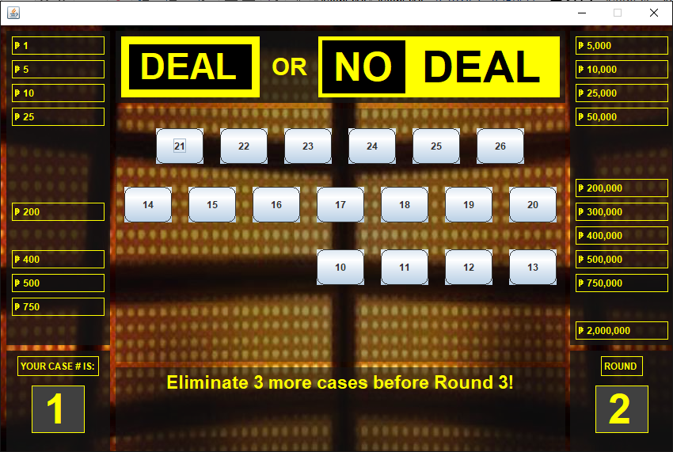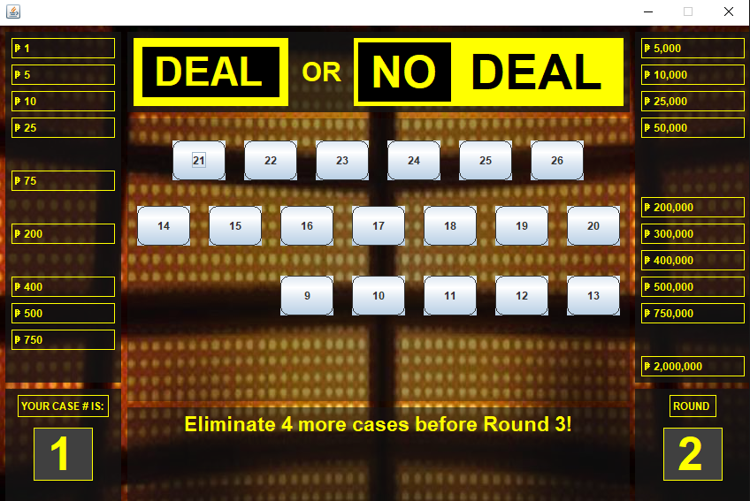**ROUND 2**

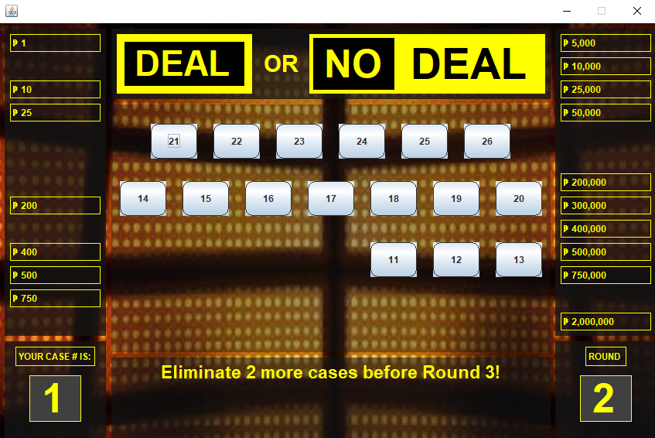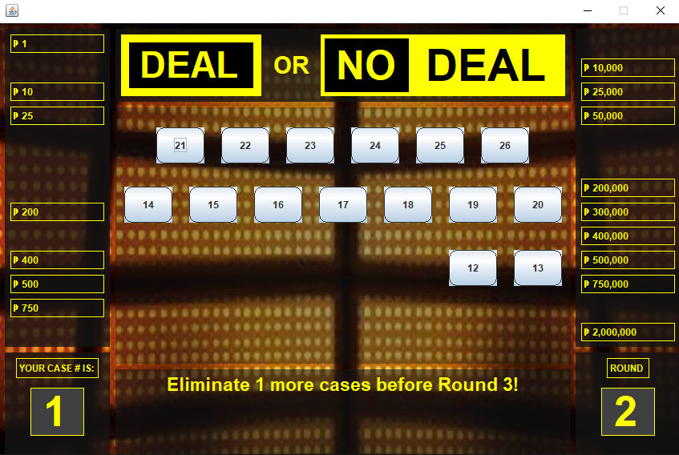

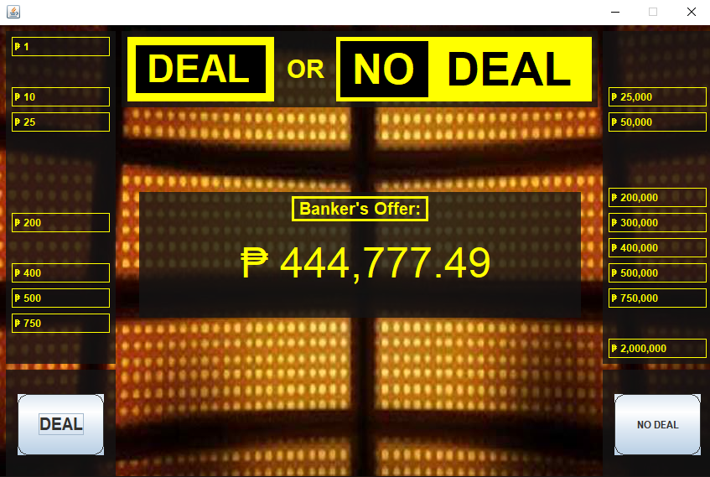**2ND DEAL OF BANKER**

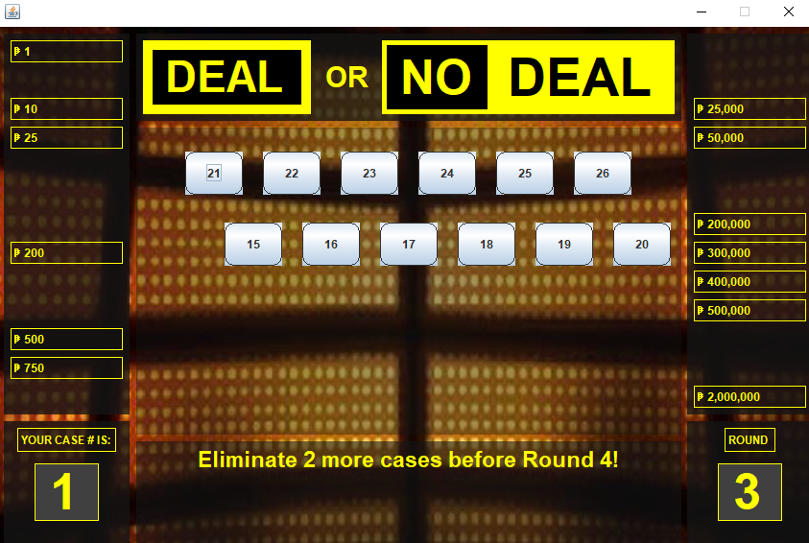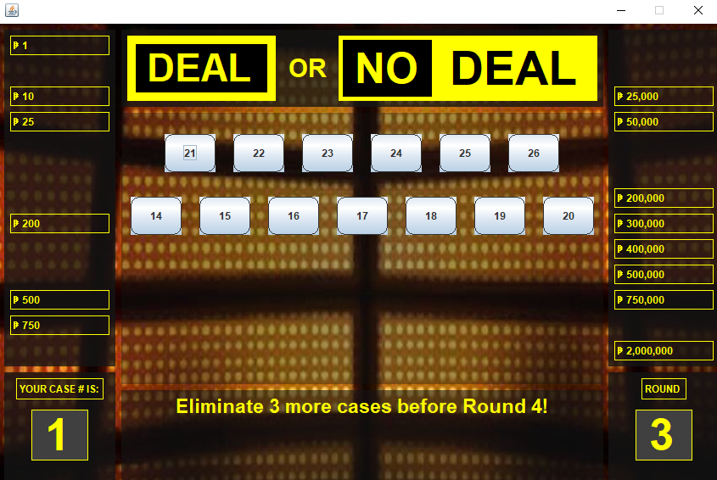**ROUND 3**

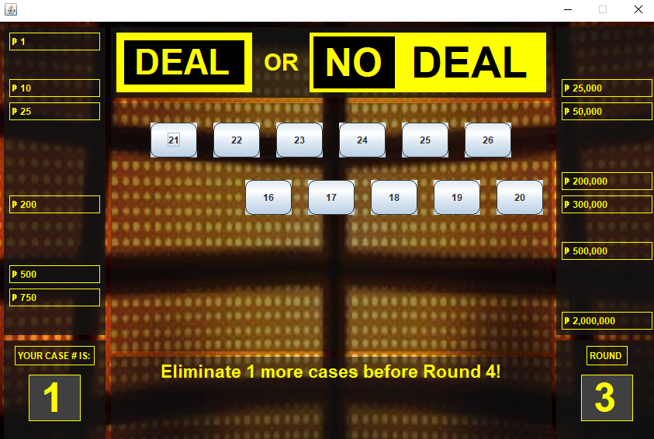

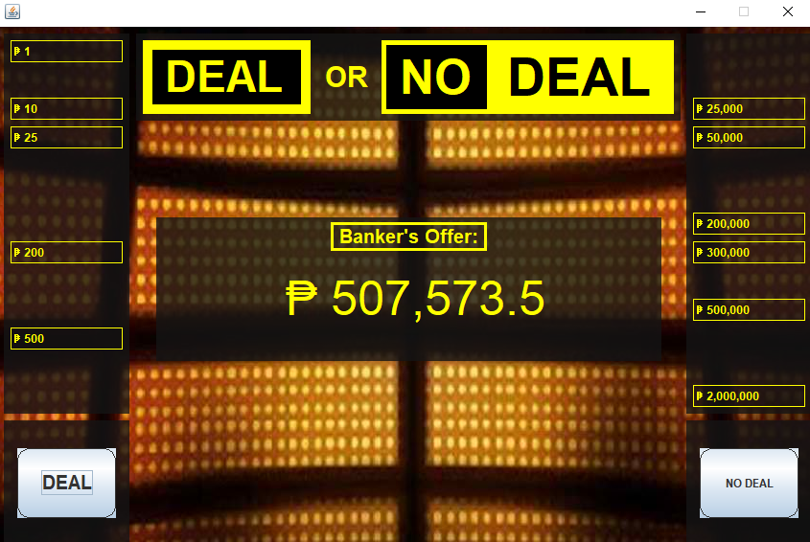**3RD DEAL OF BANKER**

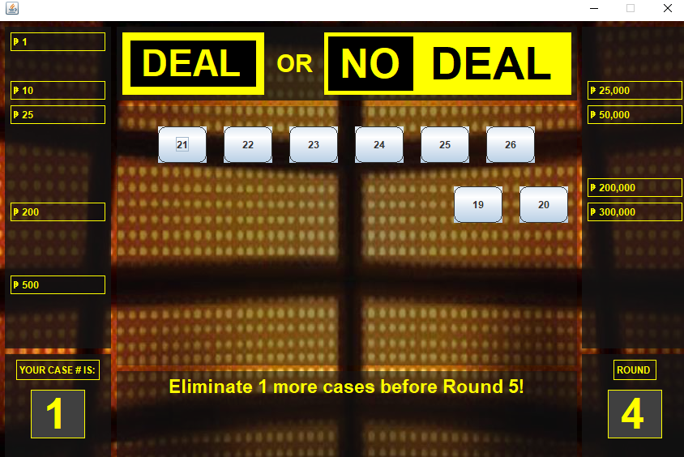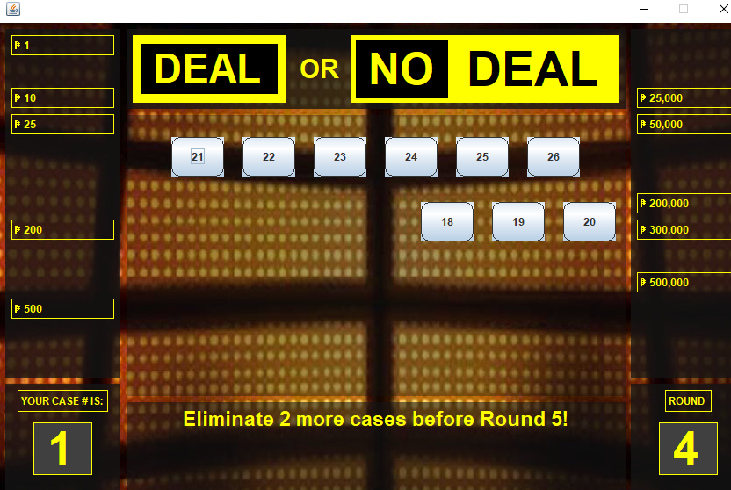**ROUND 4**

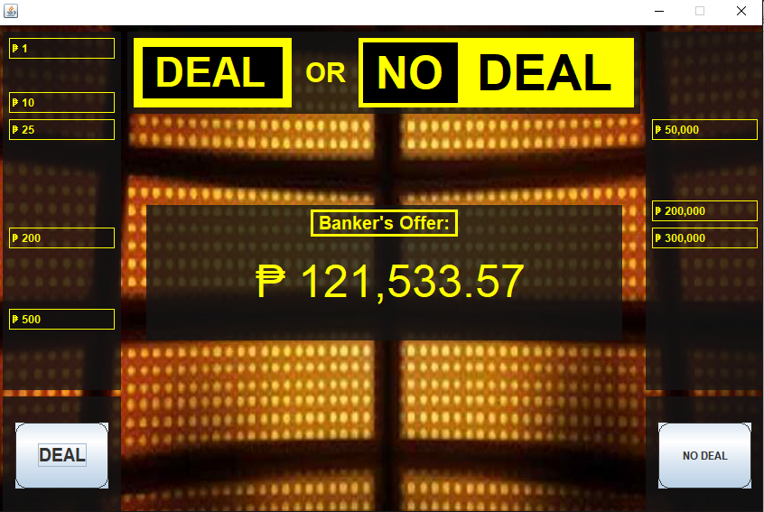**4TH DEAL OF BANKER**

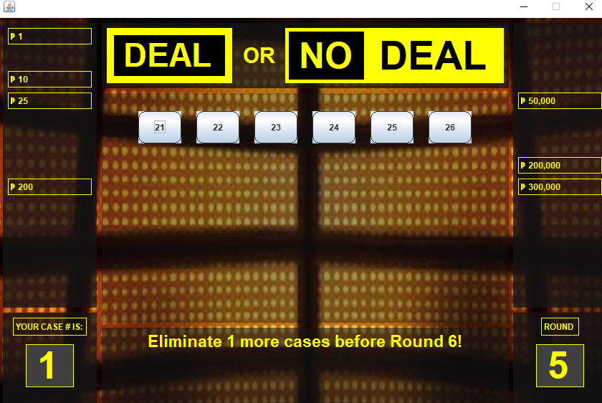**5TH ROUND**

**5TH DEAL OF BANKER**

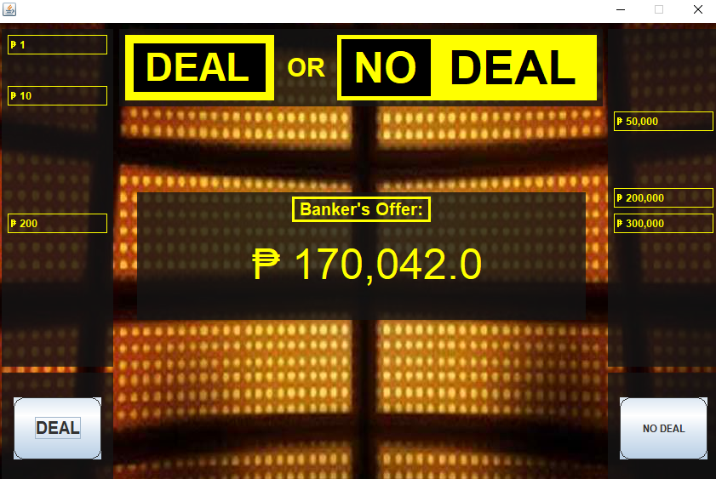

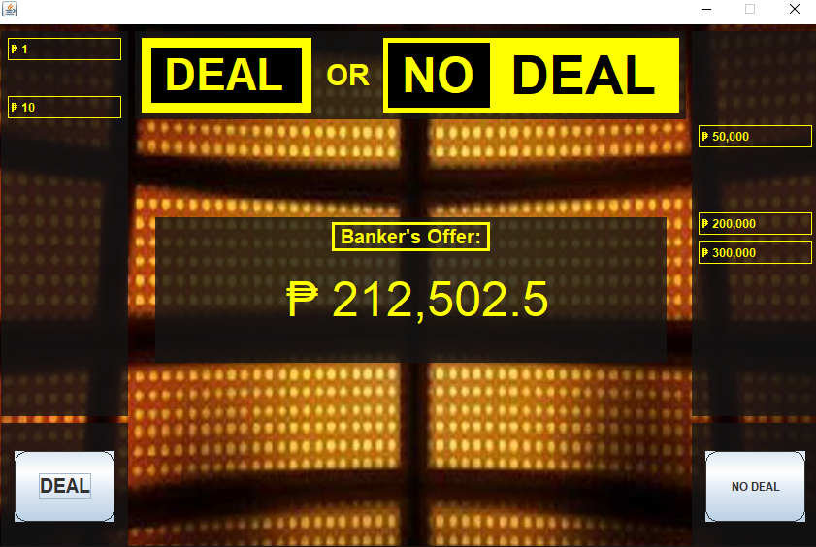**6TH DEAL OF BANKER**

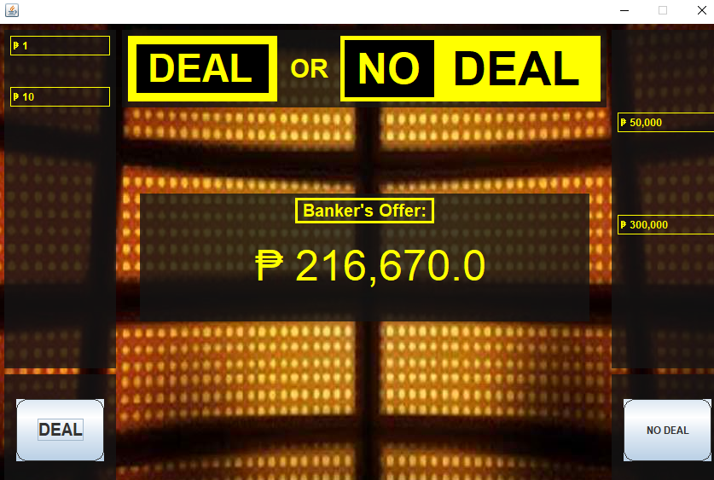**7TH DEAL OF BANKER**

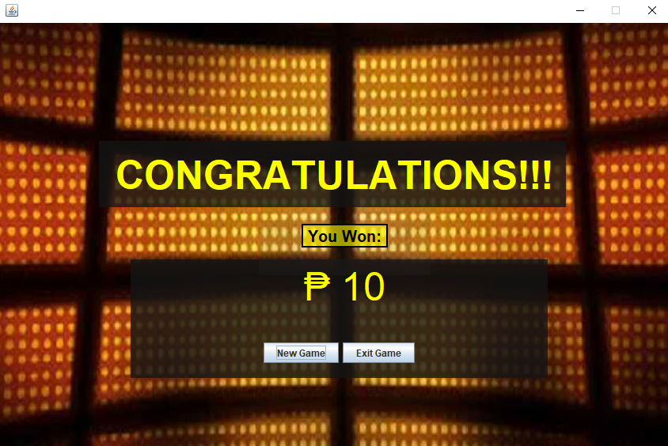**WIN**